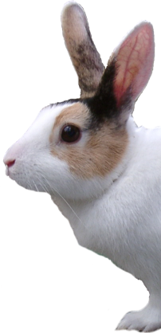
We Don’t Sell Rabbits Because…

We’re supporting rescue centres by not contributing to the over population of pet rabbits.

1000’s of Rabbits Are Waiting for Homes in Rescue Centres.

Some have been neglected, left in tiny hutches with inadequate food, bedding or health care. Others were brought as children’s pets only to be discarded like an old toy when the child became bored.

If you can provide a permanent, caring home to a rabbit please visit:

www.RabbitRehome.org.uk

Or contact your local rescue centre.

